**Features-Network: a Automatic Decision Model for Regression Test Scope Selection**

Intel DCSG EPSD BIOS &Firmware Validation Team, Shanghai, P.R.C.

Correspondence: [yifan.li@intel.com](mailto:yifan.li@intel.com), peng.xue@intel.com

* **Overview**

BIOS or BMC (Baseboard Management Component) Firmware test case library contains hundreds of cases, e.g. 500+ for BMC firmware test, which correspond to various features of them. It’s quite difficult, but significant to select the regression test cases when a new feature comes or a bug emerges.

The previous approach, rely on engineer’s practices experience, is to choose likely affected features/cases for regression test, the scope will vary from person to person.

The selection procedure is shown in Figure 1, and in which our goal is to build an automatic decision system tool, Features-Network (FN).

Figure 1: a process diagram illustrates the procedure of regression test features selection, red module is our main task.

* **Method**

A new method is presented to resolve the problem in our Demo, using one digraph with weight values, shows the dependence between one feature (cases cluster) and everyone else, rather than the individual experience. Figure 2 illustrates part of the data structure.

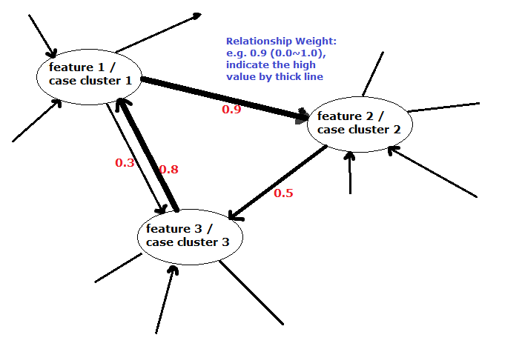

Figure 2: A digraph with Weight-Values indicates the relationships between one feature and the others.

e.g. in this figure, “0.9” means that “feature 2” is heavily depended on “feature 1”, in terms of the Weight range 0.0 ~ 1.0

The requested regression test features/cases will be obtained by means of N iterations, N indicates the iters number, and the selected node should fit the set weight-value parameters.

* **Innovations**
* To eliminate human influence to reliability and accuracy of regression test scope definition.
* To represent the complicated relationships between various features, using a digraph with weights, for quick selection.
* To build a high efficient reusing method, base on existing data and digraph, for repeated regression test task.
* To propose a model to resolve similar problems, also present in other teams.
* **Expectation**
* Offer a novel idea and reference points to our colleagues.
* The method is quite simply and easy to implement, but sharply reduce engineer’s workload and keep the validation process’s stability.
* A demo shown as below:

